Countdown Timer

CSE321 Fall 2021: Project 2

Misha Nelyubov

October 31, 2021

Table of Contents

01. Introduction 1

02. Specifications 1

03. Features 1

04. Applications 1

05. Block Diagram 1

06. Functionality Diagram 1

07. BOM 1

08. Schematic 2

09. Test Plan 2

10. Results 2

11. Recommendations for Improvement 2

# Introduction

# Specifications

# Features

# Applications

# Block Diagram

# Functionality Diagram

ASM, FSM State Diagram, or Flow Chart (Pick 1)

# BOM

The following collection of components will be required to construct the timer:

Hardware:

* NUCLEO L4R5ZI microcontroller
* 4x4 matrix keypad (8-pin)
* JHD1804 LCD
* Solderless breadboard
* USB 2.0 A to USB 2.0 Micro B cable
* Four (4) LEDs
* Eight (8) 1kΩ resistors
* Jumper wires (recommended to have at least 14)

Software

* Mbed Studio (<https://os.mbed.com/studio/>)

# Schematic

The following set of schematics describes the set of electrical connections between the NUCLEO and peripheral devices required to create the timer.

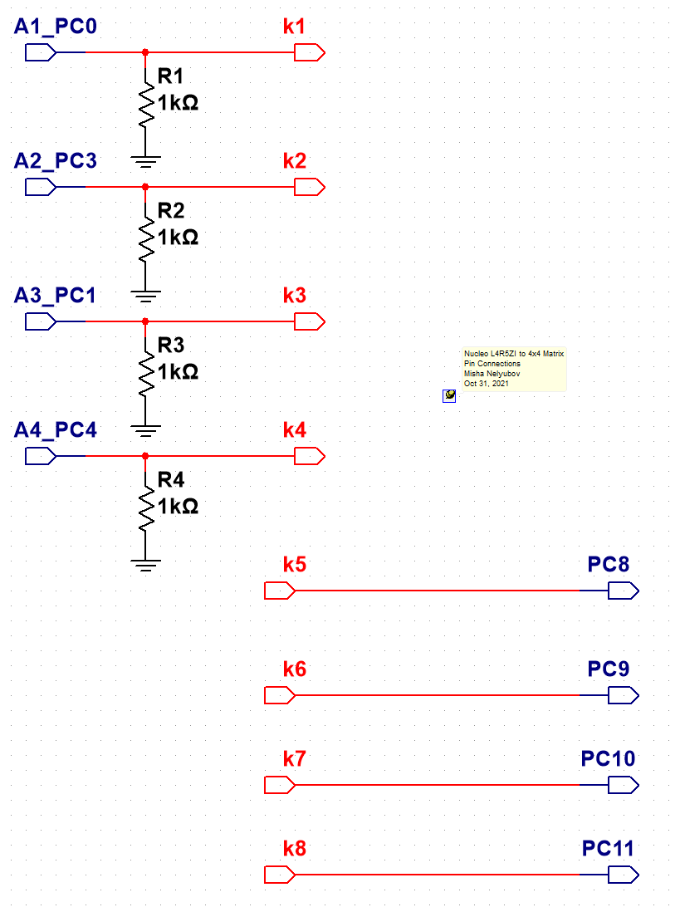

Figure 1. The eight pin connections between the NUCLEO microcontroller and 4x4 matrix keypad. Connectors k1-k8 represent pins 1-8 of the matrix keypad.

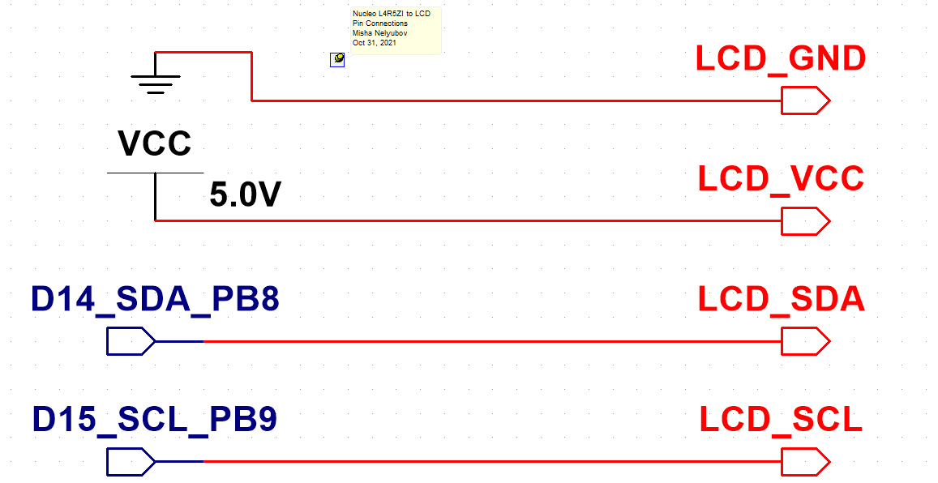

Figure 2. The four pin connections between the NUCLEO microcontroller and LCD.

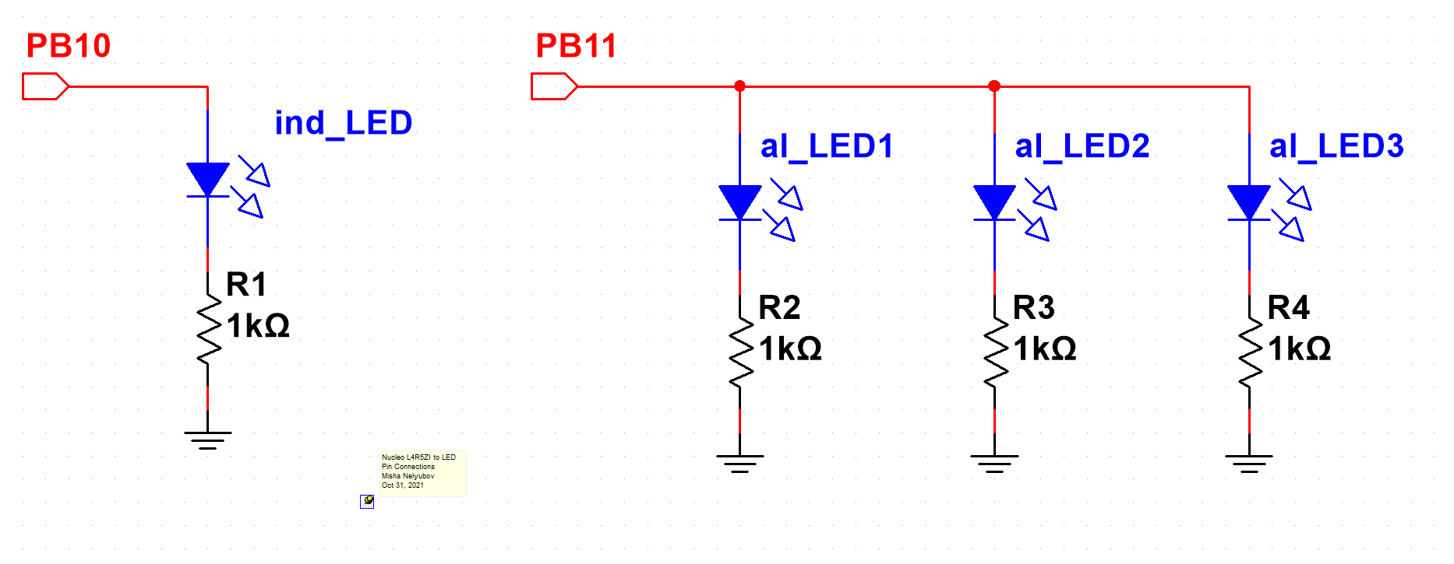

Figure 3. The two pin connections between the NUCLEO microcontroller and the indicator and alarm LEDs.

# Test Plan

# Results

# Recommendations for Improvement

* 1. Increase duration
  2. Add sound output when alarm sounds